St. Peter’s Lutheran School
Supply List
2023-2024

Mrs. Burns’ K-2 Classroom
12 inch wooden ruler with cm side not bendable
1 pkg. of eraser toppers for pencils
scissors
1 large box Kleenex
2 boxes markers-both primary
Colors (NOT skinny tip)
water color paint set
5” x 8”school box with flip lid
2 folders with pockets
1 coloring book
2 boxes of 24 crayons each
backpack
4 glue sticks (small)
1 container disinfectant wipes
1 paint shirt (old large T-shirt)
Second grade – wide ruled paper
Not bound - loose

Ms. Ali Conway’s 3rd-5th Room
Bible (ESV)
12- #2 pencils
12 inch wooden ruler with cm side
Scissors
Eraser
Colored pencils
10 pack of washable markers
1 box of 24 crayons
2 black Sharpies
Highlighters – 4 colors
4 glue sticks (small)
1 bottle of glue (small)
Calculator
2 pkg loose leaf paper – wide ruled
4 wire bound notebooks (70 – 100 pages) –
wide ruled
3 folders with pockets
1 package white note cards (100)
1 package eraser toppers
1 container disinfectant wipes
2 boxes of Kleenex
1 water color paint set

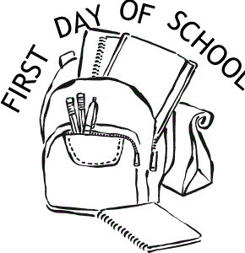

Mrs. Day’s 6th-8th Room
12 pack #2 pencils
1 pkg. eraser pencil toppers
2 red pens
2 Sharpies
4 highlighters- yellow, orange, pink, and green
1 pink eraser
Scissors
Colored pencils
10 pack washable markers
2 glue sticks
1 bottle of glue
3 packages of loose-leaf paper – college rule
4 pkgs. Notecards on rings
Bible (ESV)
Metal compass
Calculator (must be Model TI 30xa!)
6 spiral bound notebooks
6 folders with pockets
1 canister disinfectant wipes
1 three ring binder 2”
1 package binder dividers
1 - protrator

