The Raider Reporter
Feb 3, 2025

"I am the Alpha and the Omega," says the Lord God, "who was, who is, and who is to come, the Almighty." Revelation 1:8.
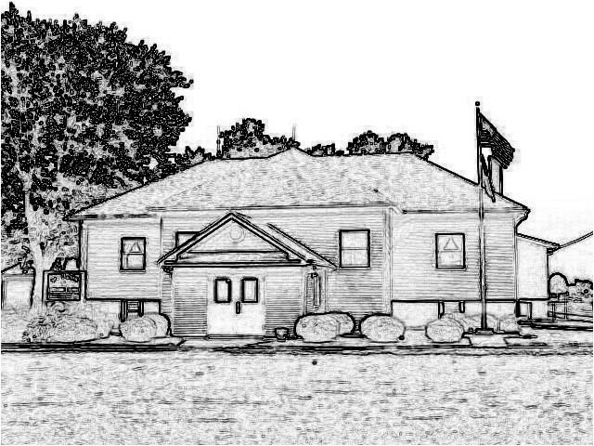

Mrs. Lavezzi’s Class
Here comes February!
We will have lots of special activities this month with Groundhog's Day, President's Day, Valentine's Day, and lots of other fun stuff.
This week we will start by learning about groundhogs and why we have a special day for them.
Later in the week we will start on Valentine's Day which will continue into next week.
This week we will also be starting our winter assessments in preparation for parent teacher conferences later this month.
Be looking for an email to sign up for a time to meet.
In Second Steps we will be learning about naming feelings to help us calm down.
Bible story of the week is Jesus teaching us not to worry because he will provide for us.

Mrs. Burns’ Class
In Bible Time this week we will learn how strong David's faith when he defeated Goliath.
For story time we will begin some Valentine's books.
ALL students will need to bring in some type of box to decorate that we will decorate in art this Friday for our Valentine's mailboxes.
We will also learn more about Groundhog's Day, and in science begin a unit on habitats that God created for all our wonderful creatures.
Wednesday is also 100 DAY, so remember to bring in those bags filled with 100 items!
Memory: All - Love the Lord your God with all your heart, with all your soul and with all your mind.

Ms. Brust’s Class
Welcome to week 23 of the 2024-2025 school year!
English: We are continuing chapter 7, focusing on Pattern 2 sentences, verb transitive, and direct objects.
Reading: Grades 3-8, we are finishing our current novels, My Side of the Mountain and The Giver.
Math: This week we will work on lessons 75-78, with a test on Tuesday.
Spelling: We will be working on pages 96-99 and will have our spelling test on Friday.
Social Studies: We will be continuing chapter 4, focusing on moving to the Midwest
Science: We will be finishing chapter 4 and will have our chapter test next week.
Have a wonderful week!

Mrs. Day’s Class
Science: we will be studying Vertebrates, Ectotherms and Amphibians. There will be 3 labs this week.
Social Studies: we will finish the early life of the church, Ch 13. Journal and Test will be next Tuesday.
Math: We will complete lessons 64-68.
Enjoy the beautiful weather today!
Have a blessed week!

Students of the Week
Cyler Hartley is in third grade.
His favorite things to do are work with his dad, ride four wheelers, and play with his sister.
At school he likes math because it is fun, and he plans to play with his friends a lot this school year.
Steak is his favorite food.
God bless Cyler!

23-24 Yearbooks
Yearbooks are available at school. They cost $20 each.

PreK-2 Snacks
Monday-Bell
Tuesday-Felis
Wednesday-Woszczynski
Thursday-Patton
Friday-Santoro
next Monday-Robertson

St. Peter's Trivia Night and Silent Auction
Our Parent Teacher League will host our trivia night and silent auction on Friday, February 28. Doors open at 6:15 PM with silent auction bidding.
Trivia will be starting at 7:00p. The cost is $15 per person with a maximum of ten people at your table.
Mulligans will be available for purchase for $1.00 each with a maximum of ten.
We welcome any donations for our silent auction.
Popcorn and soda are FREE!
Groups are welcome to bring in your own food.
Call 618-888-2252 to reserve a table!
St. Peter's students are not charged the entry fee.

January Readers
Remember to turn in your January reading logs this week.
New February logs will be passed out today!

February Lunches
A calendar is attached to our February lunch menu. YUM!

Lunch for the Week

Monday
Pizza
Salad
Fresh Fruit

Tuesday
Chicken Pot Pie
Green Beans
Peaches

Wednesday
Farmer’s Delight
Peas
Applesauce

Thursday
Turkey Melt
Fresh Veggies
Pears

Friday
Taco Crunch
Corn
Fresh Fruit

Dates:
Feb. 12 - SID Rep. Mr. Fick visit
Feb. 17 - No School President's Day
Feb. 28 - 7:00PM Trivia Night and Silent Auction
March 14 - No School End of 3rd
Quarter
March 24-28 Achievement Testing

