The Raider Reporter
April 7, 2025

"I am the Alpha and the Omega," says the Lord God, "who was, who is, and who is to come, the Almighty." Revelation 1:8.
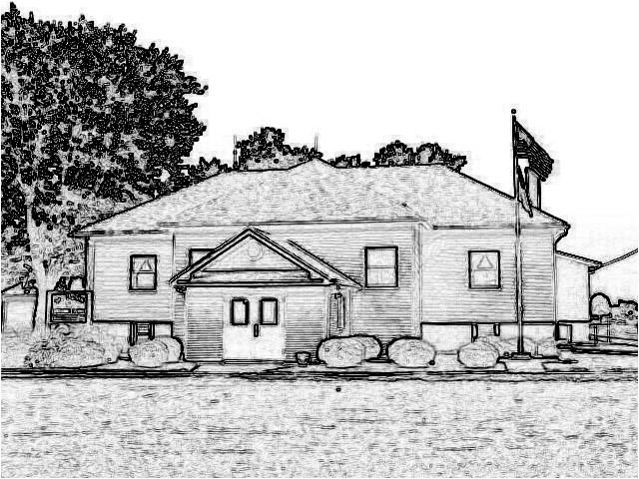

Mrs. Lavezzi’s Class
As Easter quickly approaches, we will be using it as our learning theme for the week.
During Second Steps last week we learned the first part of solving a problem is to say what the problem is outload.
This week we will work on the second half, which is thinking up solutions.
We will review the fair ways to play while doing this.
In Bible time we will finish the Easter story using the Resurrection Eggs.

Mrs. Burns’ Class
In Bible Time this week we learn about Holy Week leading up to Jesus’ crucifixion.
Kindergarten is learning about the vowel digraph, oo, and starting long vowels with a sneaky e.
We continue with musical practice.
In science we will learn about our senses of sight and touch by taking a close look at the eye and skin.
1st and 2nd continue their chapter book studies.
No memory as we are learning a lot of new Bible songs for our musical .

Ms. Brust’s Class
Welcome to week 32 of the 2024-2025 school year!
English: We are starting chapter 11, focusing on pattern 4 sentences, using linking verbs and predicate nouns.
Reading: We are continuing with independent reading pages.
Math: 4th/5th Grade: We will work on lessons 103-106, with a test on Thursday.
3rd Grade: We will work on lessons 106-110.
Spelling: We will be working on pages 132-135 and will have our spelling test on Friday.
Social Studies: We will be starting chapter 6, focusing on the West side of America.
Science: We will be starting chapter 13, focusing on maintaining body systems.
Have a wonderful week!

Mrs. Day’s class
Science: We will be covering Mitosis and Meiosis, and Karyotyping. We will complete one lab on the Manufacture of Insulin.
Social Studies: We will be completing Britain’s American colonies, Ch 23.
8th graders will be completing a practice Federal Constitution test on Friday. The actual test will be next Tuesday, 4/15. Please encourage them to study their note cards.
Math: Math 1 Lessons 96-100; Math 2 Lessons 87-95; Algebra Lessons 95-100.
Have a blessed week! I’m thankful for this sunny day!

PreK-2 Snacks
Monday-Wiemers
Tuesday-Wallace
Wednesday-Lavezzi
Thursday-Burns
Friday-Bell
next Monday-Santoro
next Tuesday-Felis

Student of the Week
Jase Myers is in sixth grade.
At school his favorite subject is religion class, and this year he plans to adjust to middle school.
His birthday is July 5, so he gets to have a great fourth of July celebration!
His favorite book is about the Holocaust.
Outside of school he likes to ride ATVs.
His favorite food is chicken strips with ranch.
When he grows up, he wants to be a mechanic.
God bless Jase!

McDonald's Day
We look forward to McDonald's Day on Monday, April 14!
Thanks for getting all the order forms in!

March Readers
Our March Readers are Karlie Patton, Elena Robertson, Margot Thyer, Nora Thornton, Emma Patton, Betty Thyer, Lyla Wiemers, Natalie Bivens, and Lenox Howald.
Over 6 months these readers have read over 6,000 minutes expanding their academic success.
Way to go!
To qualify for the lunch date out of school students needed to participate each month.
We will contact parents with information about possible lunch dates.

Spring Pictures
Spring pictures are THIS Wednesday, April 9.
Order forms are attached. Remember you can keep your form until you view the photos online to choose your favorites.
Order forms will then be due on Monday, April 14.

Palm Sunday
All children are invited to carry palms into church on Palm Sunday, April 13.
We will meet in the annex of the church between 9:45-10:00 AM.
Children will return to sit with their parents following the processional.

Easter Breakfast
We have a great group of volunteers to help with Easter Breakfast.
All are welcome to attend our 6:30 AM Sunrise Service and 7:30 AM Breakfast.
We serve breakfast casseroles, donuts, fruit salad, and drinks.

Easter Egg Hunt
We will host an Easter Egg Hunt behind church at 9:30 AM on Easter.
Children up to grade 2 are welcome to hunt for some treats!

Baby Shower
Mrs. Lavezzi's baby is due in June.
We will be hosting a Pampers and Huggies diaper and wipes shower for her on Friday, April 25, at 2:00 PM. Families are invited to attend!
We look forward to welcoming Baby Lavezzi!

K-8 School Musical
This year's K-8 Musical is called, "Judge Julie Truly."
We investigate the case of the Holey Roof made by the friends of a lame man who wanted to see Jesus and ask for healing.
Our performance will begin at 6:30 PM on Thursday, May 1 in our gymnasium.
We hope to see you there!

End of Year Field Trip
Attached is our permission slip for the Preschool to 8th grade field trip on Wednesday, May 14, to the Museum of Transportation in St. Louis.
Please return these slips with payment for adults by Wednesday, April 23.

VBS Fun
Our Vacation Bible School is scheduled for July 14-17 from 9:00-11:30 AM. Mark your calendars!

Lunch for the Week

Monday
Pizza
Salad
Fresh Fruit

Tuesday
Cheese/Hamburger
Green Beans
Peaches
Wednesday
Open-Face Pizza Burgers
Fresh Veggies
Applesauce

Thursday
Spaghetti
Peas
Pears

Friday
Taco Crunch
Broccoli
Fruit

Next Monday
McDonald's

Next Tuesday
Chicken Enchiladas
Ceasar Salad
Fresh Fruit

Dates:
April 9- Lenten meal at 5:30p.
service at 7p
April 13- Confirmation; Palm
Sunday; 9:45 AM Children meet to carry palms into church
April 14 - McDonald's Day
April 14-15 - No Bus
April 17- Maundy Thursday service at
7p; First Communion
April 18- Good Friday service at 7p
April 16-21 - Easter Break No School
April 20- Easter Sunday services at
6:30a & 10a; 7:30 AM Easter Breakfast in school cafeteria
April 25 - 2:00p Diaper shower for
Mrs. Lavezzi
May 1 - 6:30 PM K-8 Musical
May 2 - No School
May 5-9 Teacher Appreciation Week
May 9 - 2:15 Egg Drop
May 11- Mother’s Day
May 14 - PreK-8 All School Field Trip
May 15 - 6:30 PM PreK four and
Kindergarten Graduation
May 16 - Last Half Day at 11:00
Dismissal
May 18 - 10:00 AM 8th Grade
Graduation Worship Service
July 14-17- VBS 9-11:30am

