The Raider Reporter
September 02, 2025

"Put on the full armor of God” Ephesians 6:13-18.
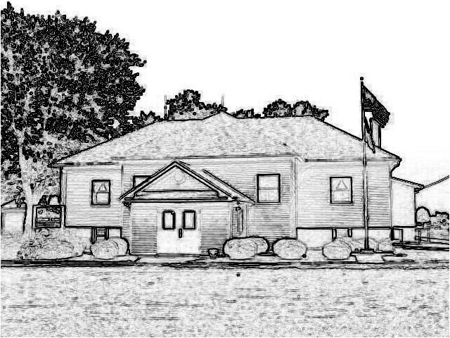

Mrs. Burns’ Class
Two full weeks complete, and we are set to learn! Bible time this week will be about the faith of Noah and his trust in God's promises. Kindergarten will continue with letter, G, and begin letter, H. Finding things around your home with these letter sounds really reinforces these concepts. In Science will will learn about the property of matter called solids. Memory: The Third Commandment - Remember the Sabbath Day by keeping it holy.

Ms. Woszczynski’s Class
What a fantastic start it has been! Your children are setting into routines, strengthening friendships, and showing great enthusiasm for learning. We will be discussing God’s promise to Abram. This will be week 3 of memory, your child may say memory any time during the week but it must be said by Friday. The Third Commandment: Remember the Sabbath day by keeping it holy. What does this mean? We should fear and love God so that we do not despise preaching and His Word, but hold it sacred and gladly hear and learn it.The Fourth Commandment: Honor your father and your mother that it may be well with you and thou mayest live long on the earth. What does this mean? We should fear and love God so that we do not despise or anger our parents andother authorities, but honor them, serve and obey them, love and cherish them.
Grammar this week will be going over types of sentences and using our grammar skills to write an expository writing piece.. Reading group A this week will be focusing on interpreting the author's purpose and reading an informational text about whales and sharks. Reading group B this week will focus on explaining the author's reasoning and purpose and continue reading our realistic fiction book The Year of the Dog. 3rd grade math will be working counting coins and comparing their values along with adding 10 to 2 digit numbers. 4th grade math will begin to work on geometry such as shapes, line segments, and angles, along with naming fractions. 5th grade math we will work on division with/without remainders and the associative property. We will begin a new science chapter on energy from natural resources.

Mrs. Day’s class
Science: We will finish our crystal project this week. There will be a Test on Thursday covering Introduction to Earth Science.
Social Studies: We will review Ch 2, Exploring the Americas. There will be a test on Tuesday. The period boat project is due on Wednesday. We will then start Ch 4, Colonial America.
Math: We will complete Investigation 1 and lessons 11-13.
Have a blessed week! Enjoy the amazing weather!

PreK-2 Snacks
Monday- NO SCHOOL
Tuesday- Walkington
Wednesday- Glatt
Thursday- Wiemers
Friday- Hill
next Monday- Santoro

If you send a snack that needs a spoon, please send these along with the snack bag.

On Monday, Wednesday, and Friday we need 21 snacks and on Tuesday, Thursday we need 11 snacks.

New Web Address
Our new website is www.saintpeterslutherans.org We added and s to the old one. Remember you can pay your tuition online if you would like.

NO SCHOOL October 2-3
There will be No school on October 2nd and 3rd for the National Lutheran Education Association Convocation.

Fall Pictures
Dinnius Photography will take our fall school pictures on Wednesday, September 10. An order form is attached. You are welcome to wait until after pictures are posted online to turn in your order form.

2024-2025 Yearbooks
Last year's yearbooks have arrived! If you ordered one at registration, please send in $20, and we will send them home with your student. Terri Dinnius said that 5 people paid for a yearbook, but she did not write down who it was. Please let me know if you already paid for a yearbook and we will get you a copy.

3rd-5th Field Day
Mrs. Woszczynski's class will be headed to MELHS on September 16. We will need drivers for this event, so please contact her if you are able to go along and help that day. Students will need to bring water, sunscreen, and their lunches. Attached is a permission slip for grades 3-5 for the field day. Please return these by Wednesday, September 10.

Dates to Save
PreK-1st Eckert's Grafton Apple Farm trip will be September 19 leaving at 8:15 from school.
PreK-8th Grade Boonie's Pumpkin Farm October 19 leaving school at 10:00am.
Bells & Sing in 10:00am worship service September 28

Book Orders
Place your orders at scholastic.com by September 19. When you check out, "Connect to a Teacher" so that you can enter our school in Dorsey, IL.

Volleyball Camp
Mrs. Burns will be hosting a volleyball camp on Tuesdays starting September 9 from 3:00-4:30 for girls and boys in grades 2-8. Be sure to bring shorts and tennis shoes and be ready to have a good time learning about volleyball. We will meet September 9,16, 23, and 30th.

Lunch for the Week

Monday
No School

Tuesday
Pizza
Caesar Salad
Fresh Fruit

Wednesday
Ham and Cheese Macaroni
Broccoli
Peaches

Thursday
Turkey Melt
Fresh Veggies
Applesauce

Friday
Chicken Fajitas
Green Beans
Pears

Dates:
Sept. 10 - Picture Day
Sept. 16 - MELHS Field Day for Grades 2-5
Sept. 19 - 8:15 PreK-1 Grafton Eckert's Apple Farm
Sept. 28 - Kids sing/bells at 10:00AM worship for our church's 170th Anniversary
Oct. 2 & 3 – No School- National Lutheran Education Assoc. convocation
Oct. 3-4 - 6th-8th grade Camp Wartburg
Oct. 13 - No School Columbus Day
Oct. 17 - 10:00 AM PreK-8th Boonie's Pumpkin Farm
Oct. 23 - 3:00pm-8:00pm Parent Teacher Conferences
Oct. 29-31 - No Bus

