The Raider Reporter
Sept 16, 2024

"I am the Alpha and the Omega," says the Lord God, "who was, who is, and who is to come, the Almighty." Revelation 1:8.
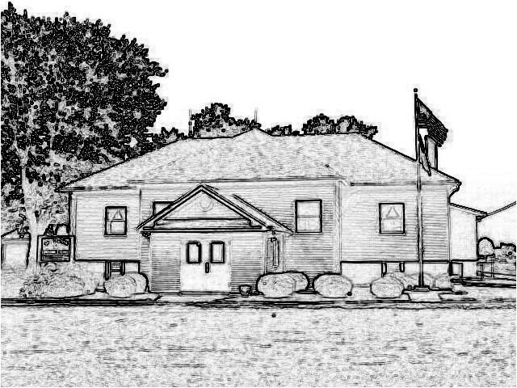

Mrs. Lavezzi’s Class
It's Apple Time!
This week we will be starting our apple unit which will take us to the end of the month.
We will also continue the alphabet with letters TIH and practicing horizontal and vertical lines.
The Bible story for the week will be Jacob and Rachel having a baby.
Second Steps will be a review of our listening and focusing skills.
Don't forget picture day on Wednesday and Apple Trip on Friday!

Mrs. Burns class
We will continue learning about Father Abraham this week, his wife Sarah, and his son, Isaac.
Our language arts stories and writings will revolve around apples since we are so excited about our Apple Farm trip on Friday.
In social studies we will learn how goods get to market, including apples.
During science we will use microscopes to look closer at insects and learn about the seasons of an apple tree.
We will have a short art class on Thursday and learn about Johnny Appleseed and try our best to draw him with an apple orchard.
Memory: All - 7th Commandment: You shall not steal.
1st-2nd: You shall not give false testimony against your neighbor.

Ms. Brust’s class
Welcome to week 5 of the 2024-2025 school year!
This week we have a field trip to Metro-East Lutheran High School for their Field Day on Tuesday.
We will be leaving St. Peters at 8:30am to arrive at Metro-East around 9:00am.
English: We will be starting our first writing assignment.
Reading: 3-5: We will continue reading our novel The Magic Finger and filling out our online Response Journals on Google Classroom.
6-8: We will continue reading our novel Tracker, chapters 7-10, and filling out our online Response Journals on Google Classroom.
Math: This week we will work on lessons 16-19 and will have our 3rd test next week.
Spelling: We will be working on pages 32-35 and will have our spelling test on Friday.
Social Studies: We will be discussing cause and effect.
Science: We will be talking about measurements and the mass of objects.
Have a wonderful week!

Mrs. Day’s Class
Science: We will be studying Taxonomy and Classification. Also, we will be completing 2 labs on Osmosis and a DNA model.
History: We will be starting Ch 4, Mesopotamia. There will be a Test/ Journal review on Friday.
Math: Lessons 19-20 will be completed along with a Test on Thursday.
Have a blessed week!

PreK-2 Snacks
Monday-Walkington
Tuesday-Ponce
Wednesday-Wiemers
Thursday-Thyer
Friday-No Snack Field Trip
next Monday-Eden

Picture Day
THIS Wednesday,
September 18 is our all-school picture day.
Order forms do not have to be turned in that day. You are welcome to wait to see the photos on her website and choose your favorites.
Mrs. Burns will email families when the photos are ready for viewing.

PreK-2 Apple Farm
THIS Friday, September 20, is our apple farm trip to Grafton Eckert's Apple Farm.
We will leave school at 8:20 AM. Before our tour we would like to take a group photo at the entrance and use the restrooms before our tour begins at 9:30 AM.
Pack lunches if you choose to eat there.
Please let your teachers know when you are leaving, so we can be sure all children are accounted for, and we appreciate all our volunteer drivers.

3rd-5th Grade Field Day
THIS Tuesday, September 17, is our MELHS field day for grades 3,4, and 5.
Pray for good weather and be sure to pack lunches, plenty of water, and sunscreen.
We thank all our parent drivers.

Looking Ahead
All grades PreK-8th will visit Boonies Pumpkin Farm on Friday, October 25, from 9:00-11:30. We will return for lunch and afternoon classes.

Book Orders
Scholastic book order forms were sent home last week. Online orders are due by September 30. Be sure to choose St. Peter's Lutheran so we can rack up those bonus points.

TJ's Pizza Sales
We hope your sales are going well.
If you need more order forms, please let us know.
When taking payments, please make check payable to St. Peter's School.
These order forms will be due Monday, September 30th.
All orders will be delivered to our school on Wednesday, October 16.
Please be sure to pick up your orders that day as we do not have enough freezer space to store them.
We truly appreciate your help with this Fall fundraiser.

Family Fellowship Night
Families with children under 18 are invited to join us on Wednesday September 18th 5-8pm at the playground behind the school for a time of fellowship.
Please bring any items to help your family enjoy the event comfortably such as lawn chairs, blankets, and food and drinks.

Monday
Pizza
Salad
Fruit

Tuesday
Open Face Pizza Burger
Green Beans
Peaches

Wednesday
Cheeseburger Macaroni
Peas
Pears

Thursday
Lasagna
Fresh Veggies
Applesauce

Friday
Cheesy Nacho Bake
Broccoli
Fresh Fruit

Dates:
Sept 17 - 3rd-5th Field Day
MELHS
Sept 18 - Picture Day
Sept 18 - 5-8:00 Family Fellowship
Sept. 20 - PreK-2 Grafton Apple
Farm
Sept 30 - TJ's orders due
Oct. 1 - Pop a Good Book Reading
Program begins
Oct. 11 - No School Bloomington
Oct. 14 - No School Columbus Day
Oct. 16 - TJ's pizza order pick up
after school
Teacher Conference
End of First Quarter
Oct. 17 - Parent/Teacher
Conferences 3:00-8:00 PM
Oct. 18 - No School
Oct. 25 - PreK-8 Boonies Field Trip
9:00-11:30 AM
Oct. 30 - Dress Up Day and Fall
Party 1:30 PM
Oct. 31 - October Reading Forms
Due
Nov. 7 - Grandparent's Day

