The Raider Reporter
September 18, 2023

"Grow in God's Love - I am the vine; you are the branches. Whoever abides in Me and I in him, he bears much fruit. John 15:5
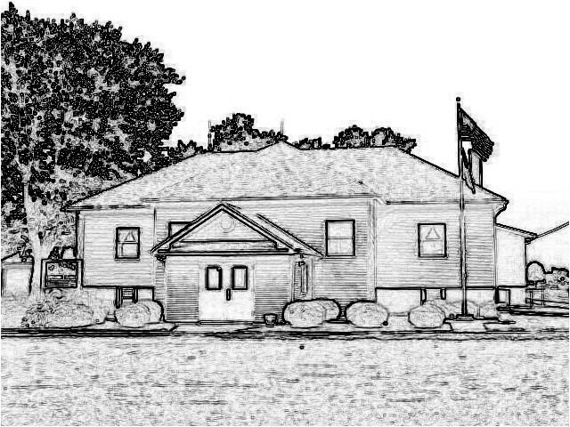

Mrs. Lavezzi’s class
This week will be all about apples as we prepare for our field trip on Friday. We will learn about how apples grow, what we use apples for, and get to try some different apples.
In second steps we will talk about following directions.
Bible time will be about Jacob's Dream.
Letters for the week will be T, I, and H.

Mrs. Burns class
More miracles fill our Bible Time. This week we learn about Jesus calming the storm and healing of Jairus' daughter.
In English second graders will learn about singular, plural, common and proper nouns.
During story time we will listen to two stories about trees and journal about our favorite trees and how God wants us to treat our trees.
In social studies we learn about environment regions and how we can care for them.
In science we will investigate how matter sinks or floats.
Memory: All – The Seventh Commandment – You shall not steal. 2nd – The Eighth Commandment – You shall not bear false testimony against your neighbor.

Ms. Conway’s class
Welcome to week 5! This week we will be heading to Metro East Lutheran for our Field Day on Tuesday. Please don't forget to pack your child a lunch! We will be leaving school at 8:30 AM and returning around 2:00 PM.
We will finish up School Days According to Humphrey and take a final quiz over Chapters 13-15 on Friday.
Students will have list 4 for spelling this week and will take their test on Friday.
In math, we will cover lessons 17-20.
We will talk about static electricity and electrical currents in science.
For art, each student will be making their own scarecrow in honor of the first official day of fall on
September 23!

Mrs. Day’s Class
We enjoyed a morning of cooking last Friday, making brownies and cheesecake cookies from scratch. Students enjoyed choosing the recipe, making a supply list, baking, measuring and tasting! We learned a few lessons for the next baking session.
In Science, we are learning about changes of state including melting, vaporization, evaporation, condensation and sublimation. We did an experiment on melting ice and making a chart. We will have a test on Wednesday.
In History, we are studying about the First President, the new economy, early challenges and the first political parties. We will have a test on Tuesday.
In Math, we will work on Lessons 19-23. We will have a test on Thursday.
The students took awesome pictures and enjoyed the fun picture! Thanks to Dinnius Photography!
Student of the Week
Jason Wiemers is in preschool, and his favorite subjects in school are art, reading, and music. His favorite sport is baseball, and he is really good at puzzles. He loves his sister, mom, and dad. Tickles make him laugh. He is good at puzzles and looks forward to playing with his sister, Lyla. When he grows up he wants to be a dad. God bless Jason!
PreK-2 Snacks
Monday-Walkington, Tuesday-Wiemers, Wednesday-Allen, Thursday-Hartley, Friday- No Snack Field Trip, and next Monday-Green

PreK-2 Apple Farm
This Friday, September 22, we will pack our lunches and head to the Eckert's in Grafton. Please turn in permission slips by Wednesday. If you prefer to meet us there instead of coming to school first, please let Mrs. Burns or Mrs. Lavezzi know by Thursday. Our tour begins at 9:30, so we will leave the school at 8:30 AM.

Scholastic Book Orders
Today your child was given a Scholastic Book Order Form. ALL orders will be placed online. For our school to get credit and earn points for our order, we will need you to enter our school name and teacher Melissa Burns. Simply scan the code on the order form with your device, enter your birthdate, enter our school zip code 62021, search for St Peters Lutheran, click on Melissa Burns Teachers, and then create your parent account. Orders will need to be placed by September 27 for the September catalogs.

TJ’s Pizza/Cookies Fall Fundraiser
All sales order forms and money will need to be turned in by Monday, October 2. Delivery of sold items to our school will be Wednesday, October 18. We sure appreciate everyone's help with these sales.

No Hot Lunch Days
Due to field trips,
September 19 and September 22 there will be no hot lunch served at school. All students need to pack lunches either for the field trip or for lunch at school.

MELHS Field Day
Our 3rd-5th grade class with Ms. Conway will be headed to Metro East Lutheran High School on Tuesday, September 19. Students will need to either bring lots of water and a lunch or bring money for the concession stand.

Dates:
Sept. 19 - 3rd, 4th, 5th MELHS
Field Day
Sept. 19 - Pack lunch
Sept. 22 - PreK-2 Grafton Apple
Farm
Sept. 22 - Pack lunch
Sept. 29 - Scholarships Awarded
Oct. 6 - No School Teacher's
Conference Good
Shepherd
Oct. 9 - No School Columbus
Day
Oct. 13 - PreK-2 Millstadt
Pumpkin Farm
Oct. 13 - No bus - Pack Lunch
Oct. 19 - Parent Teacher
Conferences
Oct. 20 - No School
Oct. 27 - Fall Party 1:30 PM and
Dress Up Day
Oct. 30 - No bus
Oct. 31 - No bus
Nov. 1 - No bus

Lunches

Monday
Pizza
Salad
Fruit

Tuesday
No lunch

Wednesday
Farmer’s delight
Peas
Pears

Thursday
Ham melt
Green beans
Peaches

Friday
No lunch - field

