The Raider Reporter
December 4, 2023

"Grow in God's Love - I am the vine; you are the branches. Whoever abides in Me and I in him, he bears much fruit. John 15:5
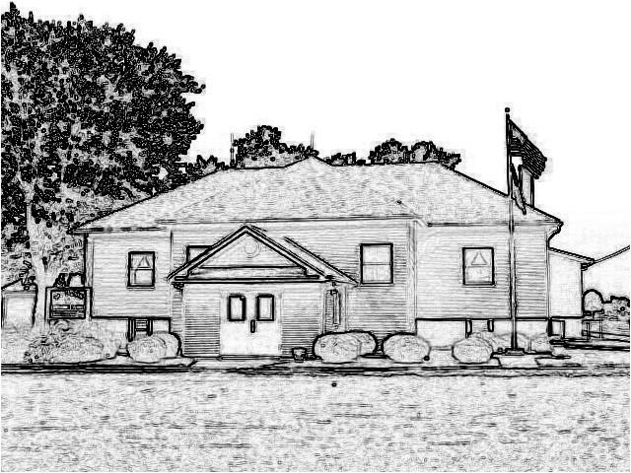

Mrs. Lavezzi’s Class
Welcome December! We will be focusing on Christmas all month long.
We will finish up the alphabet this week with letters that switch directions S and Z.
The Bible story for the month will be going through the Christmas Story.
In Second Steps we will talk this week about feeling worried.
Names for our gift exchange will be going home in folders today, see further in the newsletter for more information.

Mrs. Burns class
Excitement is in the air in our classroom with December upon us
Our Bible Time about the birth of John the Baptist and Mary's visit from the Angel will begin our Advent studies leading up to the birth of our Savior.
A copy of their Christmas Program parts is in their folder
today to practice for memory this week.
In Science we will earn about the energy of light and play with shadows.
There will not be Show-N-Tell this week as we will be singing Christmas songs with our school friends.
In Art class we will begin some special gifts for our special moms and dads.
Memory: All - (Parts for the Christmas Program)

Ms. Conway’s class
We will spend this week's Bible time talking about Elijah and the Prophets of Baal.
Students will have a creative writing assignment in English and will give presentations later in the week.
We will finish up Wayside School is Falling Down.
Students will have list 12 in Spelling and will have a test on Friday.
In Math, students will have a test on Tuesday.
We will wrap up the week talking more about light and matter.

Mrs. Day’s Class
Welcome to December! Wishing you and your family a blessed Christmas season.
We will be making cookies this week to share at school on Friday as well as playing pass the gift with white elephant gifts.
History-We will be studying War with Mexico and the California Gold Rush. A quiz will be on
Thursday.
Science-We will be studying Ionic bonds and covalent bonds with a quiz on Friday.
Math-We will be completing lessons 57-59. We will have a test on Wednesday.
Student of the Week
Asher Wallace is in First Grade, and he loves his sister and his teacher. At school his favorite subjects are math, computer, and reading. He is really good at soccer, and he looks forward to driving a tank. Baseball is his favorite sport, and when he grows up he wants to be a basketball player. God bless Asher!

PreK-2 Snacks
Monday-Lavezzi, Tuesday-Burns, Wednesday-Robertson, Thursday-Wallace, Friday-Walkington, and next Monday-Wiemers.

Reading – A Recipe for Success
New December reading logs went home last Friday. December forms will not be due until we return from break by January 5.

November Readers
Good job to our November readers: Asher, Cyler, Mac, Emma, Betty, Rhett, Lyla, Gia, Tessa, Katie, Liam.

Gift Exchange
Today, we drew names for our Secret Angel gift exchange. Each child is to buy a present between $10-$15 for that child whose name they drew. We have written some ideas on the cards that the students drew. Gifts can be brought to school anytime before our party on Friday, December 22, that will begin at 9:30 AM.

Snow Alerts
Our school will be listed as “St. Peter Lutheran – Dorsey” on channels 4 and 2 if we need to cancel school due to snow. We will also follow Edwardsville School District, so if they are off we are as well. We will also post the closing on our school Facebook page.

Christmas Program
On the evening of
Wednesday, December 20, we would like all students to arrive by 5:45 PM in the church annex. The program begins at 6:00 PM in the church. All students will sit with their teachers. You will pick up your child after the program also in the church annex. We look forward to sharing Jesus' story with you!

Wrapping Event
Come on out for our holiday wrapping event. All you need to do is bring your gifts to school on Dec. 9 from 4:00-8:00 or Dec. 10 from 12:00-3:00. We will do the wrapping of the gifts in exchange for a monetary donation to the school. Labels and bows will also be available to add to your gifts.

Dates:
Dec. 6 - __ 7:00 Advent Worship
Dec. 9 - Wrapping event
4:00 - 8:00 pm
Dec. 10 Wrapping event
12:00 – 3:00 pm
Dec. 13 - _ 7:00 Advent Worship
Dec. 20 - 6:00 Children’s
Christmas Program
Dec. 21 - No Bus
Dec. 22 - No Bus, Half Day 8:15-
11:00
Christmas Party 9:30
AM
Dec. 25-Jan. 2 - Christmas Break
Jan. 3 - Return to Class 2024
Lunches

Monday
Pizza
Salad
Fruit

Tuesday
Turkey tetrazzini
Green beans
Peaches

Wednesday
Farmer’s delight
Broccoli
Fruit

Thursday
Turkey melt
Peas
Pears

Friday
Chicken enchiladas
Veggies
Applesauce

