The Raider Reporter
Jan 13, 2025

"I am the Alpha and the Omega," says the Lord God, "who was, who is, and who is to come, the Almighty." Revelation 1:8.
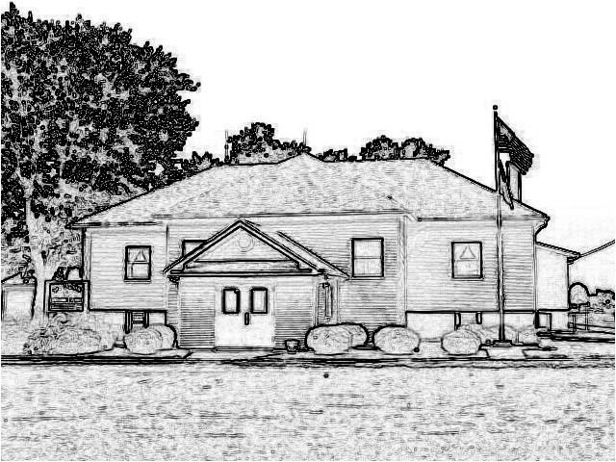

Mrs. Lavezzi’s Class
Welcome Back Finally!
We're going to hit the ground running after missing last week for snow.
We finished the whole alphabet last semester, so we will be reviewing the letters all this semester.
Getting back into Second Steps, we will be starting a new unit.
Now that we've learned about some of our feelings, we will start learning how to manage those feelings when they get big.
In Bible time we will learn about Jesus being Baptized by John.

Mrs. Burns’ Class
Welcome to 2025!
In Bible class we will learn about Epiphany and about the Wise Men who sought the star and its light.
Kindergarten will collaborate on letter C and start our next vowel-E.
In Social Studies we will learn about inventors. In Science we will start a new chapter on invertebrates.
Memory: 5th Petition - Forgive us our trespasses as we forgive those who trespass against us.
1st & 2nd grade: 6th Petition - Lead us not into temptation

Mrs. Day’s Class
Welcome back after Christmas break and the snow! Thank you so much, parents, for all of your generous gifts! You are very much appreciated!
Science: We are starting Invertebrates, Sponges and Cnidarians. We will complete Lesson reviews. We will have labs next week.
Social Studies: We will be studying Rome: Republic to Empire, with 4 lessons. Students will be completing the Ch 11 Journal or comprehension questions. We also started a World current events section to our class.
Math: We will complete a Winter Review this week.
Please keep my husband in your prayers as he has surgery tomorrow. I will be out for a few days and hope to return on Thursday.
God's blessings for your New Year!

Students of the Week
Margot Thyer is in kindergarten, and she lives in Bunker Hill with her dad, mom, and sister, Betty.
Her favorite color is green, and her favorite book is The Kid's Cookbook.
Pickles are her favorite food.
She has a pet named Brock.
When she grows up, she wants to be a Librarian.
God bless Margot!

Nora Thornton is in First Grade, and she lives in Holiday Shores with her dad, mom and sister, Wrenley.
She loves to eat pizza, and her favorite color is yellow.
Her favorite books are the Amelia Bedelia series.
When she grows up, she wants to be a police officer.
God bless Nora!

PreK-2 Snacks
Monday-Bell
Tuesday-Felis
Wednesday-Woszczynski
Thursday-Patton
Friday-Santoro
next Tuesday-Thyer

Toy Day
This Friday, January 17, students are allowed to bring in a toy to play with at recess time. We look forward to seeing what Santa brought this year!

Snow Days
It is that time of year...
In case of snow, we always follow Edwardsville School District if they cancel school.
We will also post on our St. Peter's Lutheran School -Prairietown, IL Facebook page.
We will also be listed on Channel 4 and Channel 2.

Report Cards
3rd Quarter report cards will be sent home today for grades K-8. Please contact your teachers with any questions!

Sing/Bells in Worship
As part of our National Lutheran Schools' Week, we will be singing in church on Sunday, January 26. We would greatly appreciate your attendance at our 10:00 worship service.

Science Assembly
On Friday, January 24, at 1:45 PM, the Mad Science group out of St. Louis will be coming for a Science Assembly to kick off our National Lutheran Schools' Week of January 26-31.
All families are invited to attend!

Pop a Good Book
Remember to turn in your December reading forms this week!
What a great way to spend a cold winter day with a good book and a warm blanket!

Creation & Ark Trip
Attached is a flyer for a voluntary group field trip March 12-13 to the Creation Museum and Noah's Ark Encounter to see Bible stories comes to life.
Please let Mrs. Burns know by Friday, January 17, if you would like to attend.

Lunch for the Week

Monday
Pizza
Salad
Fresh Fruit

Tuesday
Chicken Fried Rice
Broccoli
Pears

Wednesday
Cheese/Hamburger
French Fries
Green Beans
Fresh Fruit

Thursday
Chicken Alfredo
Peas
Peaches

Friday
Burrito Casserole
Fresh Veggies
Applesauce

Dates:
Jan. 17 - Toy Day
Jan. 20 - No School M.L.K. Day
January 24 - 1:45 PM Mad Science
Assembly to kick off NLSW
Jan. 26 - PreK-8th Sing/Bells in
Church at 10:00 AM
Jan. 26-31 - National Lutheran
School’s Week

