The Raider Reporter
April 22, 2025

"I am the Alpha and the Omega," says the Lord God, "who was, who is, and who is to come, the Almighty." Revelation 1:8.
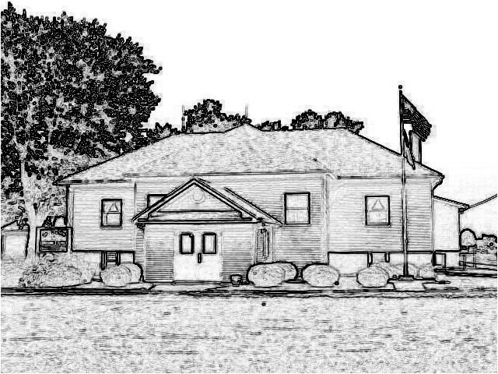

Mrs. Burns’ Class
We pray that you had a blessed Easter with your families.
We will learn more about the days after Jesus rose from the dead this week in Bible Time.
Kindergartens are learning about more letter friends like, ch and ee.
In Science we will finish up our chapter on eyes and skin.
In English we will learn about double negatives.
Memory: All - The angel said to the women, "Do not be afraid, for I know that you are looking for Jesus... 1st-2nd ...He is not here; he has risen, just as he said. Matthew 28

Ms. Brust’s Class
Welcome to week 34 of the 2024-2025 school year!
English: We are starting chapter 13 this week, focusing on pattern five sentences, pronoun-antecedent, and double negatives.
Reading: We are continuing with our independent comprehension reading.
Math: 4th/5th Grade: We will work on lessons 109-111 with a test on Thursday. 3rd Grade: We will work on lessons 113-116 with a test on Thursday.
Social Studies: We will be working on lesson 3, focusing on changes and challenges in the West.
Science: We will learning about vaccines and antibiotics.
Have a wonderful week!

Mrs. Day’s class
I hope everyone enjoyed their Easter!
Science: We will be celebrating Earth Day, Habitat search, and visiting the Zoo on Thursday, completing a scavenger hunt while there.
Social Studies: We will complete Ch 22, Ideas about the Universe. 8th Graders will start the Illinois Constitution.
Math: Each Math section will complete lessons up to lessons 104.
Have a blessed week!

PreK-2 Snacks
Tuesday-Patton
Wednesday-Woszczynski
Thursday-Ponce
Friday-Graves
next Monday-Robertson

Student of the Week
Liam Norooz is in 7th grade, and at school he enjoys art and reading because they are fun and interesting.
His favorite things to do are draw and play ball tag.
He enjoys going to Raging Rivers Waterpark.
BBQ ribs are his absolute favorite food.
Jurassic Park is his favorite book.
His birthday is March 27, and in the future, he plans to be an oceanographer.
God bless Liam!

McDonald's Day
We look forward to McDonald's Day on Monday, April 14!
Thanks for getting all the order forms in!

March Readers
We are set to go out to lunch on Thursday, April 24, at 11:45 to the Village Drive Inn in Bunker Hill.
Karlie, Emma, Elena, Margot, Betty, Nora, Lyla, Natalie, and Lenox read all six months.
Congratulations!

Baby Shower
Mrs. Lavezzi's baby is due in June.
We will be hosting a Pampers and Huggies diaper and wipes shower for her on Friday, April 25, at 2:00 PM. Families are invited to attend!
We look forward to welcoming Baby Lavezzi!

K-8 School Musical
This year's K-8 Musical is called, "Judge Julie Truly."
We investigate the case of the Holey Roof made by the friends of a lame man who wanted to see Jesus and ask for healing.
Our performance will begin at 6:30 PM on Thursday, May 1 in our gymnasium.
We hope to see you there!

Field Trip Permission Slips
Please turn in your field trip slips with payment for adult chaperones by Wednesday, April 23.

VBS Fun
Our Vacation Bible School is scheduled for July 14-17 from 9:00-11:30 AM. Mark your calendars!

Kite Week
May 5-9 we will be praying for a windy day to fly kites.
We ask that our preschool to 2nd graders bring in a kite to fly for that week.
These kites can be brought in at any time and are placed on the balcony in the gym.

Lunch for the Week

Monday
No School

Tuesday
Pizza
Salad
Fresh Fruit

Wednesday
Grilled Chicken Wrap
Peas
Pears

Thursday
Lasagna
Green Beans
Applesauce

Friday
Cheesy Nacho Bake
Broccoli
Peaches

Dates:
April 25 - 2:00p Diaper shower for
Mrs. Lavezzi
May 1 - 6:30 PM K-8 Musical
May 2 - No School
May 5-9 Teacher Appreciation Week
May 9 - 2:15 Egg Drop
May 11- Mother’s Day
May 14 - PreK-8 All School Field Trip
May 15 - 6:30 PM PreK four and
Kindergarten Graduation
May 16 - Last Half Day at 11:00
Dismissal
May 18 - 10:00 AM 8th Grade
Graduation Worship Service
July 14-17- VBS 9-11:30am

